Figen Suchanek

Chem 6004: Theoretical and Physical Methods

Prof. Snyder

7/3/2019

**Question #1: Once you complete your simulation, how do you anticipate being able to identify whether the water in your system is liquid or solid?**

Once I complete my simulation, I would be able to identify whether the water in my system is a liquid or solid based on examining the particle arrangement, looking at the space between them, their movements and checking how they pack (hold) together.

|  |  |  |
| --- | --- | --- |
| Water | Solid | Liquid |
| Particle movement | Particles vibrate (jiggle) about their fixed positions and do not move from place to place or around and cannot move/slide past one another (rigid). | The particles vibrate, move around quite fast and slide past each other. |
| Particle arrangement | Particles are locked into the place in a ordered arrangement  (regular pattern) | No regular arrangement but still close together |
| The space between the particles | Particles have small space between them but larger than the liquid water* | Particles have small space between them but smaller than in solid water* |
| Forces of attraction between the particles | The forces hold  the particles together | The forces do not hold the particles together |

*Normally, if the molecules are solid, the particles have small spaces between them, if the molecules are liquid, the particles have small space between them that are larger than in a solid. In water, the particles have larger space between them in solid (ice) than in liquid (Figure 1).

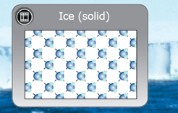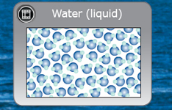

Figure 1. Water molecules in solid (ice) and liquid water.

**What qualitative feature(s) can you use to distinguish between liquid and solid water?**

I would distinguish the state of water in my system by evaluating the particle arrangement, particle movement, the space between the particles and how the particles pack together.

**Is there any quantity (i.e. numerical “measurement”) you could use to identify whether the water in your system is a liquid or solid? (Hint: what happens to water when it freezes at a constant pressure**

Water is one of the few known substance whose solid form is less dense than liquid. The density of ice is 0.917 g/cm3 (at 0oC) that is less than liquid water (0.9998 g/cm³ at 0 °C). That’s why ice floats on the water and the pipes burst in winter. The expansion between -4o and 0o is due to the formation of larger hydrogen-bonded aggregates. Above 4o thermal expansion sets in as vibrations of the O-H bonds becomes more vigorous, tending the shove the molecules farther apart (In our system, measuring the densities of ice and liquid water somehow may be difficult).

**Question #2**: Why do we leave “create disulfide bonds” selected?

In our system, the pseudomonas syringae bacteria produce “ice nucleation” proteins (1INA) that facilitate freezing (Figure 2). The heat of fusion of released by freezing water warms the bacteria and the crystals (formed by the freezing water) damage plant tissue, releasing nutrients on the bacteria can feed.

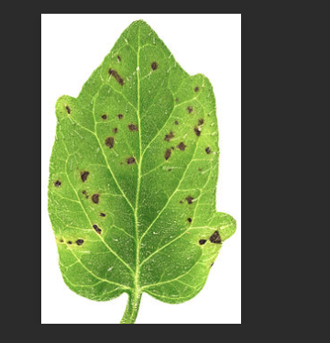

Figure 2. Pseudomonas syringae bacteria on the plant (black dots), which produces a surface protein that serves as nuclei around which ice crystals form at warmer temperatures than usual.

During the process, disulfide bonds (in the protein) are formed in an oxidizing environment. The most common way of creating this bond is by the oxidation of sulfhydryl groups (2 RSH →RS-SR+2 H++2 e-) (Figure 3). This process of oxidation can produce stable protein dimers, polymers, or complexes, in which the sulfide bonds can help in protein folding. The process mostly occurs with the thiol groups in cysteine.

[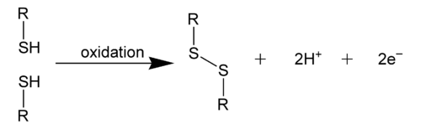](https://commons.wikimedia.org/wiki/File:Disulfide-bond.png)

Figure 3. Formal depiction of disulfide bond formation as an oxidation.

Many proteins rely on disulfide bonds for the stability of their folded state. Disulfide bonds are not made and broken in isolation, but only under certain conditions that are under experimental control. The rates and equilibrium of the process can be varied and measured, making it possible to measure experimentally the relative free energies of individual disulfide bonds. This provides unique information about protein stability and folding that is not obtainable directly with other interactions, such as hydrogen bonds or Van der Waals interactions.

**Question #3**: How many stages does your calculation have?

Summary of user stages:

Stage 1 - task (system set up: import the protein group-1INA, remove waters, select solvent model: TIP4EW, minimize the volume, ion placement (maybe))

Stage 2 - simulate, Brownian Dynamics NVT, T = 10 K, small timesteps, and restraints on solute heavy atoms, 100ps

Stage 3 - simulate, NVT, T = 10 K, small timesteps, and restraints on solute heavy atoms, 12ps

Stage 4 - simulate, NPT, T = 10 K, and restraints on solute heavy atoms, 12ps

Stage 5 - solvate_pocket

Stage 6 - simulate, NPT and restraints on solute heavy atoms, 12ps

Stage 7 - simulate, NPT and no restraints, 24ps

Stage 8 - simulate

8 stages in total